Risk Assessment Assignment
Akhielesh Srirangam

Company: Tesla(Fig 0.)
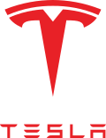
Fig 0.

OVERVIEW:

The risk assessment analysis is being performed on Tesla Inc. which is an automotive manufacturing company specializing in electric vehicles and clean energy based in Palo Alto, California, United States. Tesla Motors was founded on July 2003 by martin Eberhard and Marc Tarpenning who sold a majority stake to Elon Musk in 2004 with an investment of $6.5 million dollars. The company rolled out its first production vehicle Roadster in 2009 which put the company in the public spectrum. The company went public in 2010 and was renamed from Tesla motors to Tesla Inc. in 2017. The company manufactures electric vehicles and clean energy solutions like production of electricity to storing them. Tesla’s mission is to “accelerate the world's transition to sustainable energy”. Over the years the company has become one of the largest manufacturers of automobile to the largest manufacturer of electric vehicles. The company has an estimate of over $100 billion dollarsas shown in Fig 1. Some of Tesla’s products are Model S, Model 3, Model y, Model X, Roadster, semi-truck, solar panels, solar roofs, wall battery charger, etc. The company has gained a massive fan following and great trust by its investors over the past decade. Tesla hopes to provide a wider range of vehicles that are cost effective and sustainable so that the world can move to a greener solution. The company is focusing on developing full self-driving cars that can transport passengers with ease, the company is also working on other project like underground tunnels to transport any vehicle at top speeds like a train on a track but with lower cost and higher efficiency.
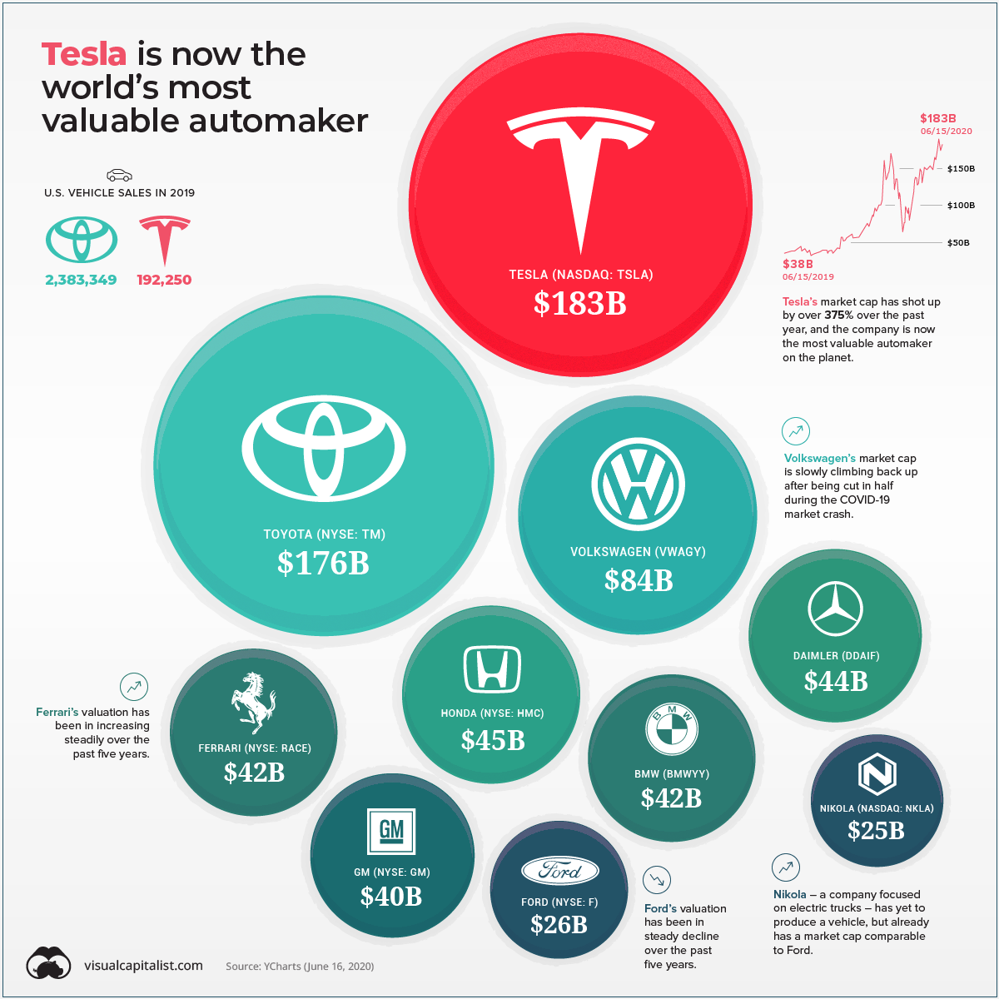

Fig 1.
THREAT AND RISK ANALYSIS:

Tesla since its inception has faced a great challenge to provide vehicles that can perform as well as a gasoline vehicle in terms of speed, range, and cost. Vehicles that run on gasoline provide a wide range of options to customers starting from the size, range, performance, speed, and cost. There are hundreds of car manufacturers for gasoline vehicles but only a few for electric vehicles. The risk began from the idea and the competition around it but has come a long way since. The company has moved from just a manufacturer of vehicles to much more involving manufacturing, software, material research, design, and other parts. When creating a new product that has not been sorted out by other companies, yet you have to start designing and building from scratch and tesla had anticipated that risk and was prepared for it. Creating an electric engine for a small device varies from a vehicle it involves more power and energy. The technology surrounding the electric vehicles was not available and was built from ground up. Tesla has worked towards the development of batteries by investing billions in both research and development. Any company that puts its product in the market needs to prove its worth and tesla used this by investing heavily in software technology by adding Artificial Intelligence (AI) into their vehicles and system. They developed self-driving technology which involved great support by their customers as they relied on that data to develop more advanced algorithms.
As they developed on these technologies, they had relied on other third-party companies to manufacture various parts in the past. This created a lot of risk and trust that they had to put on the companies, there are always risk involved in a business and much more in a developing business that has no background. The company must rely on the global process to manufacture their vehicles, this often includes both natural and man-made risks. To categorize the risk, we can classify the types of risks that the company can face. Each of these risks are viewed and analyzed from the general and cybersecurity perspective, referring Fig 2.
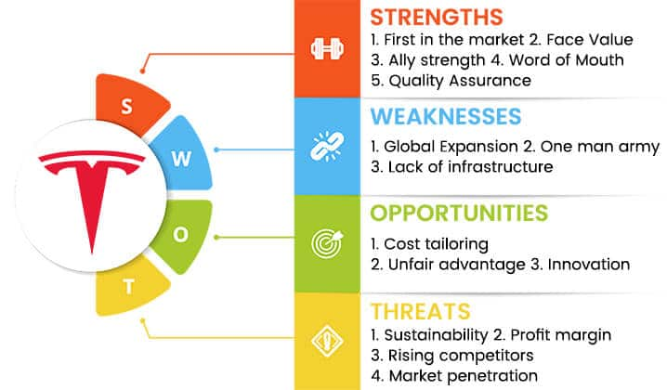
Fig 2.

- Natural threats
Natural threats are events that occur outside of man-controlled events like natural disasters, weather change, storms, pandemics, public health, facility fixtures etc. In most cases it is not possible to detect weather related risks which can cause delays in supply chain leading to production delays. It can also involve the material loss during transport which can cause delays until it can be replaced. One example that we can relate to is the COVID-19 pandemic that has disrupted the global process and supply chain. Manufacturing has reached unrecoverable delays in some cases leading to shutdown of many companies. Despite supply chain process being disrupted Tesla had reached a record number of sales during the pandemic whereas many other manufacturers had to shut down the plants for a while. Despite facing a global pandemic and potential financial shutdown Tesla innovated where the rest couldn’t. One of the top features of tesla vehicles was “bioweapon defense mode” which essentially filtered the air to wipe out 99.9% of the germs circulated from out-side. Apart from this the company had introduced significant reduction in Annual Percentage rate (APR) which motivated buyers to opt Tesla vehicles compared to their other competitors.

- Man made threats:

These can be classified into unintentional and intentional threats.
Unintentional threats:
Threats that are caused by human action but without any intention to cause harm or damage. For example, when an employee works on important data but forgets to save the data to the device, working on a project without realizing someone else may be watching from the side to use that data, forgetting to process a delivery request, etc. It includes human error but not on purpose, these can be avoided by simple training or awareness activities that can be conducted with employees to reminding them to check their workplace and items before, while and after the completion of tasks. These activities may seem unnecessary, but these have caused significant damage to companies and individuals, the damage may raise from a few thousand dollars to potentially causing the company or organization to shut down. Other activities that can help is revaluation of the staff and training them with the latest skills or matching the company’s direction to updating methods. The companies can avoid monetary losses by opting insurances that can help them save when in need.

Intentional threat:
Threats caused by individual or groups to harm or damage the flow of the company. For example, intending to leak company data with other competitors, leaking company secrets publicly, etc. These events can cause significant damage to companies. Companies must perform comprehensive background check of their employees that will help reduce the risk. Having a designated team to audit and reevaluate the performance of the employees will help in understanding the need to conduct events. Some events and activities can be conducted as a foresight or anticipating a change in the environment of the work. In many scenarios companies have opted to install a failsafe in case of a crisis.

- Vulnerability:
Every perfect system is vulnerable in some way, when a secure system is setup there are a lot of steps and processes that take place including contingencies, but that doesn’t mean they are vulnerable. The systems include hardware, software, and human element. Every aspect of system can be vulnerable hardware can malfunction, software can get corrupted, and a person can be influenced to act against the system. Production of Tesla vehicles involve design, viability, cost, supply, manufacturing, and sale. For any one process that fails in production of a car the whole process is a waste of resources and time. If the design can be leaked, the design of the vehicle may not be viable in the market, cost of the project may be too expensive, supply of the materials may be short or if all else pass the product might fail. There are too many ifs in any companies process, but it depends on the checks that must be in place for each process. When it comes to cybersecurity Tesla is one of the largest software developers in the world with leading artificial intelligence and machine learning algorithms do identify and analyze different objects to attain self-driving. This software dependency makes Tesla vulnerable to various cyber risks which can harm human lives. every Tesla vehicle makes use of various hardware and software technologies which can always which can malfunction. Tesla has performed countless number of tests before launching these products. Over the past decade Tesla has had the least number of man-made risks but still making them vulnerable to other threats. Companies use various software’s to test their vulnerability in their systems most of these software’s identify the loopholes and weaknesses this system that can be used by others who intend to cause damage. . One of the biggest vulnerabilities of Tesla is the face of the company, which is Elon Musk, as seen in the past the company's performance has been increasing under his leadership, the company has also launched many other products and services which have been widely adopted. Apart from Tesla Elon Musk is also the CEO of other companies like SpaceX, the boring company and neuralink. Over the years these companies have not spent money towards marketing due to the existing craze of the company. Tesla had accepted Bitcoin as a currency to purchase their products leading to a spike in the value of the Bitcoin currency, this adoption of cryptocurrency by a prominent company like Tesla has increased the usage and value of cryptocurrencies. One other cryptocurrency that has gained a lot of value is dogecoin, referring Fig 3., this is primarily due to the mention of this cryptocurrency by the CEO of Tesla Elon Musk. this kind of a vulnerability in cryptocurrency and a company is a very risky venture as the value of the company is assessed based on its CEO.
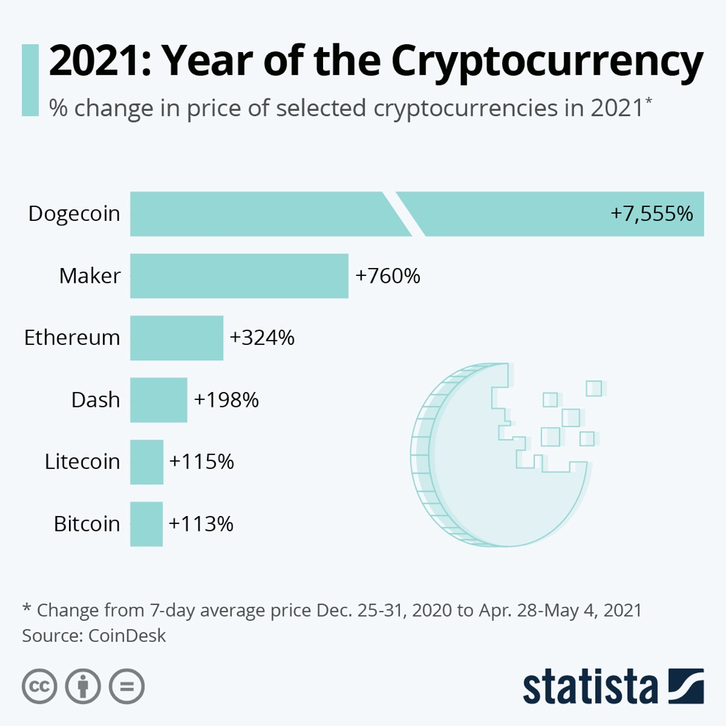
Fig 3.

- Criticality:
Criticality of the threat can be viewed as the damage caused to the company's assets, reputation, and future. Most companies take accusations against them very seriously This can cause damage to their current business. Many companies like Tesla depend on the quality assurance given by the company on their products like safety, technology, comfort, and service. Tesla has one of the safest vehicle ratings in the world and provides the highest end technology that it has to offer. Tesla has one of the most secure car safety systems in the world which make it nearly impossible to steal their vehicle. recently some researchers have been able to prove that it is possible to hack a Tesla remotely via a drone which poses significant vulnerability in the system hello. This lol so takes its intellectual property very seriously and has not shown any significant damage that has taken place in the company so far. Despite some employees leaving for other companies there has been no intellectual property theft that had damaged the company. Tesla is one of the few companies that manufacturer both its engine and the car. This gives them an advantage over the entire supply chain process.

- Impact
Impact is the loss or damage caused to the company. Most companies insure various processes and goods to cover any monetary loss. the loss incurred is calculated by the loss of business during the threat. For example, when an employee is injured during the employment period caused by the company or the company's assets the company is liable to pay for the damage caused. Another example that can be found with Tesla is a recent event where Tesla paid $1.5 million to 1700 Tesla Model S customers as repercussions for throttling the battery during a software update. Such incidences are common and often cost the company a lot of money and resources, it involves more resources to be utilized towards a same task. Some of the vulnerabilities can also include issues relating between employees leading to a risk and flaw in the policies of the company. Despite Tesla being a popular car manufacturer in the world it is yet to match the profits made by other companies since Tesla is establishing its key manufacturing facilities to increase its production of both batteries and vehicles. Tesla has been able to show profits by selling the extra carbon credits the company has achieved over the past few years despite making very less profit by manufacturing electric vehicles. Many car manufacturers like Toyota Nissan Volkswagen buy carbon credits from Tesla because they are unable to produce 10% of sustainable vehicles in a year. According to the American costs institution carbon credits are a must for the companies to produce or manufacturer vehicles. As of 2021 Tesla is not the only electric car manufacturer in the world other manufacturers have also started manufacturing close to or more than 10% of their vehicles as sustainable vehicles which makes Tesla lose its profits from the carbon credits. This will impact the company's profits in future significantly leading the company to alter its strategies.

- Capability
There are many other tech giants in the world that can attack or harming Tesla systems one of their main competitors are Volkswagen Ford and you were companies like lucid polestar which are emerging electric car manufacturers set to enter the automobile market, referring Fig 4. Despite having many competitors in the world Tesla is still the largest manufacturer of electric vehicles and leader in sustainable energy development. So far there has been no evidence of any other competitor attacking Tesla systems apart from other hackers and small illegal hacking organizations which intend to harm and disrupt large companies like Tesla. Since tesla's global expansion to China the company has received many benefits in setting up and manufacturing in the country seeming to a bright profitable future for their company. But Tesla has faced a severe backlash harming the company's reputation and the country with respect to its electric cars specifically the braking system. This incident has helped other electric car manufacturers in the country to benefit while Tesla faced a complete drop in sales, Tesla was naive to trust the country's laws where intellectual property rights benefits competitors to copy the same designs. Tesla has also seen a shortage and lithium-ion batteries, with shortage in supply for natural resources and manufacturing plants leading the company to create its own manufacturing facility for batteries, this helps the company to invest in research and development for its future. Tesla has placed several security measures starting from its products where it uses the same cameras that detect objects to detect movement or capture movements where they might have been a damage to the vehicle. the company has also placed several firewalls secure networks to process data securely.
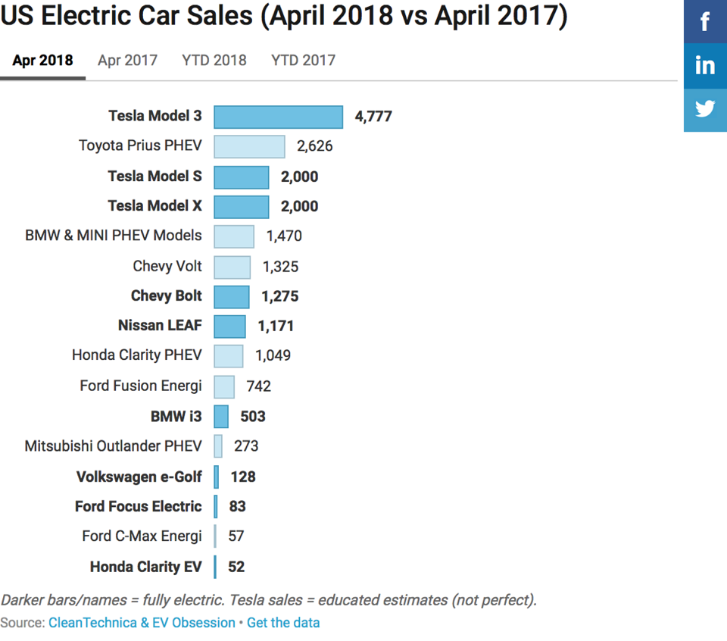
Fig 4.

- Accessibility
Much like a popular social networking application like WhatsApp Tesla also uses end to end encryption to transfer the user’s data towards secure server systems where this data is processed to better understand and analyze the future development of the algorithms. Tesla is a software company as much as it is an automobile company and issues constant and timely software updates to its products like electric vehicles to solve all bugs that may have been in the previous versions. These constant updates reduce the risk of any vulnerabilities in the system leading to smaller infiltration points for hackers and other malwares. Tesla tries to optimize the batteries via software updates to increase the performance of the vehicle and reduce the power usage. Most of the data collected from the vehicles is directly processed using the vehicles computational capabilities reducing the dependencies on an external cloud server which provides faster and accurate data outputs. The data collected by each vehicle system is sent do the Tesla servers we just checked and processed before storing in an offsite physical server.
- Intent:
Often companies like Tesla are prone to cyber-attacks by various hackers and organizations which are behind either the data collected, stored or the system algorithm itself. Most cybercrimes occur When there is a monetary profit to the hackers or organizations who intend to extort money by withholding critical data that greater harm or stop the flow of the business process.

RATING THREATS AND COUNTER MEASURES:
The severity of the threat can be classified into 3 parts minor, moderate and major, referring Fig 5. But using only severity index but likelihood can be adopted to the matrix.
Minor:
Any issue relating to system errors, no loss of few days’ business, no loss of life, no threat to companies’ reputation or no threat to company value.
Moderate:
Any issue relating to loss of business, no loss of life. But threat to companies’ reputation or threat to company value.
Major:
Issue relating to loss of life, loss of business and threat to companies’ reputation or threat to company value.
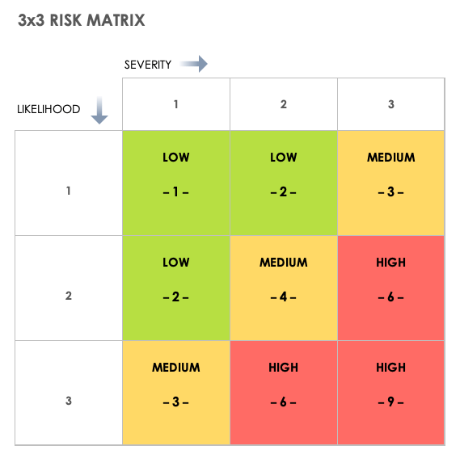
Fig 5.

COUNTERMEASURES:
- To establish a team to check the project progress with schedule
- To establish contingencies for project plans
- To secure communications, company data, company assets
- To insure company assets, supply chains, etc.
- To establish threat analysis team to check for vulnerabilities
- To develop employees and management relationship
- To offer employee benefits to achieve better performance
- To invest in research and development
- To create a legal team for threats and legal actions
- To invest in updating technology
- To organize management structure

REFERENCES:
1. https://www.google.com/url?sa=t&rct=j&q=&esrc=s&source=web&cd=&cad=rja&uact=8&ved=2ahUKEwiV47at4bTzAhXkMVkFHbbvC-UQFnoECAgQAQ&url=https%3A%2F%2Fwww.cnbc.com%2F2021%2F05%2F18%2Ftesla-electric-vehicle-regulatory-credits-explained.html&usg=AOvVaw2EXIzSciIElRcS9SWWfijK
2.
https://www.businessinsider.com/tesla-model-s-battery-lawsuit-capacity-settlement-claims-2021-7
3.
https://www.infrontanalytics.com/fe-EN/50658NU/Tesla-Motors-Inc-/gprv-risk
4.
https://en.wikipedia.org/wiki/Tesla,_Inc.
5. https://www.google.com/url?sa=i&url=https%3A%2F%2Fwww.statista.com%2Fchart%2F24793%2Fselected-cryptocurrency-price-growth%2F&psig=AOvVaw3c8t_mTu1ejMjW95WbdrTT&ust=1633578125090000&source=images&cd=vfe&ved=0CAsQjRxqFwoTCIDRwPHutPMCFQAAAAAdAAAAABAO
6.
https://www.google.com/url?sa=i&url=https%3A%2F%2Fcleantechnica.com%2F2018%2F05%2F07%2Fhuge-gap-tesla-model-3-vs-other-electric-car-sales-us-electric-car-sales-report%2F&psig=AOvVaw0MNbrrIlj_maAVQp3Qlkne&ust=1633578001165000&source=images&cd=vfe&ved=0CAsQjRxqFwoTCMD997futPMCFQAAAAAdAAAAABAO
7.
https://www.google.com/url?sa=i&url=https%3A%2F%2Fswothub.com%2Fswot-analysis-of-tesla%2F&psig=AOvVaw2-0WvbbYUuELk3ZuX4V0hv&ust=1633577905268000&source=images&cd=vfe&ved=0CAsQjRxqGAoTCJDcwYnutPMCFQAAAAAdAAAAABCqAQ
8.
https://www.google.com/url?sa=i&url=https%3A%2F%2Fwww.visualcapitalist.com%2Ftesla-is-now-the-worlds-most-valuable-automaker%2F&psig=AOvVaw2lVNhyNT6HszSEe0DIvK1k&ust=1633578300297000&source=images&cd=vfe&ved=0CAsQjRxqFwoTCLiEj8TvtPMCFQAAAAAdAAAAABAD
9.
https://www.google.com/url?sa=i&url=https%3A%2F%2Fwww.smartsheet.com%2Fall-risk-assessment-matrix-templates-you-need&psig=AOvVaw1ietK8DCfZIOnjlDXPpzCK&ust=1633578335397000&source=images&cd=vfe&ved=0CAsQjRxqFwoTCPjayNjvtPMCFQAAAAAdAAAAABAD

